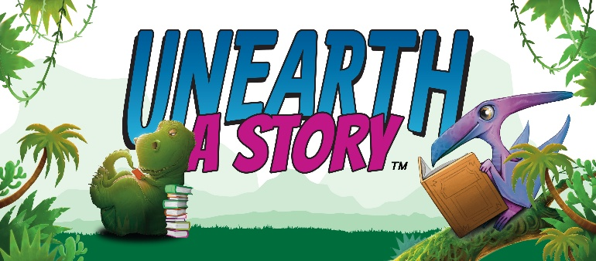

2026 Summer Reading Challenge
Early Literacy Instructions
(Age 0-5, or not yet in Kindergarten)

Each child must be registered to win prizes. Registration begins May 1st. You may register by picking up a form at the library or registering at hayslibrary.beanstack.org. Existing children with accounts will log in and click Join Challenge. Please ask staff if you cannot remember if you have an account.

Each reading milestone and each completed activity badge will receive at least one ticket to enter into the grand prize drawings. The completion of the Summer Reading Challenge will occur when you complete 20 or more badges and will result in a FREE BOOK. Paper logs can be completed for your own personal use, but all time read will be logged through Beanstack, either by yourself or staff. If you choose to use paper logs, they will be accepted at HPL or at the Bookmobile for readers without access to Beanstack from June 1st, 2026, through July 30th, 2026. If you are unable to access Beanstack, please tell staff which prize(s) you would like to enter tickets into! You can enter your prizes into as many baskets as you want.

To log on Beanstack, sign into the reader’s account and click on “log reading”. From there you can log minutes.

Paper logs are available on request. To fill in a circle on the paper log, do any of the following:
- Read for 10 minutes with your child!
- Visit the Bookmobile!

Additional tickets can be earned through Beanstack by:
- Attending a Hays Public Library class or program
- Writing reviews
- Completing activities

Tickets will be earned virtually on Beanstack to be entered into the grand prize drawings. Tickets must be entered into the drawing by 11:59 pm on Thursday, July 30th. There will be an end of summer party held at the Hays Public Library on July 31st starting at 10am.

Summer Reading Kick-Off starts June 1st at 10am!

2026 Summer Reading Challenge
Elementary Instructions
(Age 6-11, or having completed Kindergarten through 5th Grade)

Each child must be registered to win prizes. Registration begins May 1st. You may register by picking up a form at the library or registering at hayslibrary.beanstack.org. Existing children with accounts will log in and click Join Challenge. Please ask staff if you cannot remember if you have an account.

Each reading milestone and each completed activity badge will receive at least one ticket to enter into the grand prize drawings. The completion of the Summer Reading Challenge will occur when you complete 20 or more badges and will result in a FREE BOOK. Paper logs can be completed for your own personal use, but all time read will be logged through Beanstack, either by yourself or staff. If you choose to use paper logs, they will be accepted at HPL or at the Bookmobile for readers without access to Beanstack from June 1st, 2026, through July 30th, 2026. If you are unable to access Beanstack, please tell staff which prize(s) you would like to enter tickets into! You can enter your prizes into as many baskets as you want.

To log on Beanstack, sign into the reader’s account and click on “log reading”. From there you can log minutes.

Paper logs are available on request. To fill in a circle on the paper log, do any of the following:
- Read for 10 minutes with your child!
- Visit the Bookmobile!

Additional tickets can be earned through Beanstack by:
- Attending a Hays Public Library class or program
- Writing reviews
- Completing activities

Tickets will be earned virtually on Beanstack to be entered into the grand prize drawings. Tickets must be entered into the drawing by 11:59 pm on Thursday, July 30th. There will be an end of summer party held at the Hays Public Library on July 31st starting at 10am.

Summer Reading Kick-Off starts June 1st at 10am!

2026 Summer Reading Challenge
Young Adult Instructions
(Age 12+, or having completed 6th thru 12th Grade)

Each child must be registered to win prizes. Registration begins May 1st. You may register by picking up a form at the library or registering at hayslibrary.beanstack.org. Existing children with accounts will log in and click Join Challenge. Please ask staff if you cannot remember if you have an account.

Each reading milestone and each completed activity badge will receive at least one ticket to enter into the grand prize drawings. The completion of the Summer Reading Challenge will occur when you complete 20 or more badges and will result in a FREE BOOK. Paper logs can be completed for your own personal use, but all time read will be logged through Beanstack, either by yourself or staff. If you choose to use paper logs, they will be accepted at HPL or at the Bookmobile for readers without access to Beanstack from June 1st, 2026, through July 30th, 2026. If you are unable to access Beanstack, please tell staff which prize(s) you would like to enter tickets into! You can enter your prizes into as many baskets as you want.

To log on Beanstack, sign into the reader’s account and click on “log reading”. From there you can log minutes.

Paper logs are available on request. To fill in a circle on the paper log, do any of the following:
- Read for 10 minutes with your child!
- Visit the Bookmobile!

Additional tickets can be earned through Beanstack by:
- Attending a Hays Public Library class or program
- Writing reviews
- Completing activities

Tickets will be earned virtually on Beanstack to be entered into the grand prize drawings. Tickets must be entered into the drawing by 11:59 pm on Thursday, July 30th. There will be an end of summer party held at the Hays Public Library on July 31st starting at 10am.

Summer Reading Kick-Off starts June 1st at 10am!

